LEVANTINE JOURNAL OF APPLIED SCIENCES

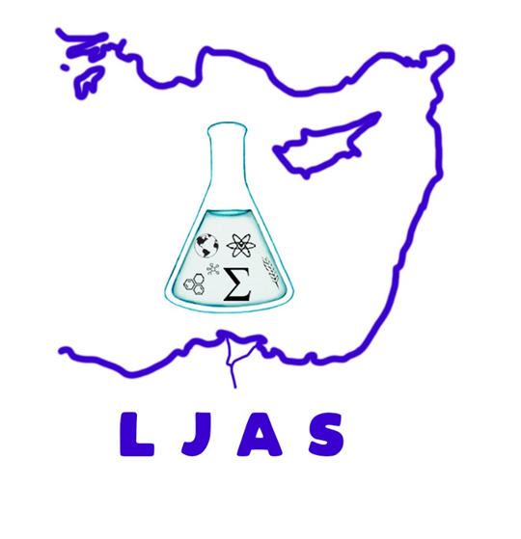

**June, 2024**

**CONTENTS**

**Original Articles**

Mustafa Hicabi Bölükdemir, Erhan Eser and Hüseyin Koç

**Gamma radiation shielding features of Bismuth Germanate glasses doped Rare-earth ions using PHITS Monte Carlo code**

Pages: 1 - 11