LEVANTINE JOURNAL OF APPLIED SCIENCES

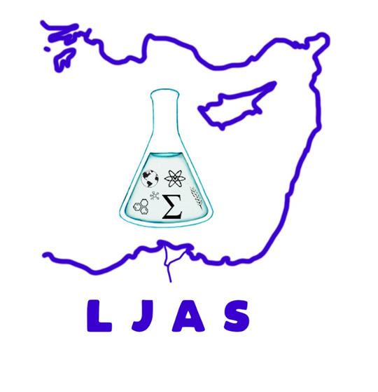

**June, 2025**

**CONTENTS**

**Original Articles**

Müberra Erdogan Karaağaçlı and Kadri Yurekli

**Assessment of Drought in the Cekerek River Basin with Satellite-Based Palmer Drought Severity Index (PDSI)**

Pages: 1 – 8

Dursun KURT and Salim ŞEKER

**Determining the Planting Time for Burley Tobacco in Samsun Ecological Conditions**

Pages: 9 - 14