LEVANTINE JOURNAL OF APPLIED SCIENCES

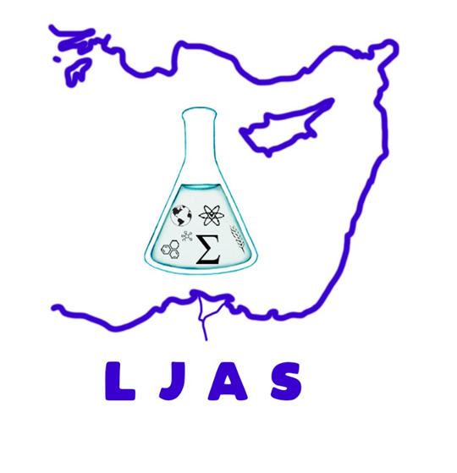
JUNE, 2022

CONTENTS
Original Articles

Kadir KANAT, Melek SOFYALIOĞLU; Selin ERDAL

Approximation by the Parametric Generalizations of the Modified Bernstein-Durrmeyer Operators
Pages: 19 - 24

Osman Nuri OCALAN, Emircan DINCER, Fatmanur CEZİK, Mehmet Emin ISBILIR, Onur SARACOGLU
Effect of Aloe Vera and Salicylic Acid Treatments on the Post-harvest Shelf Life Quality of Strawberries
Pages: 25 – 34

Miraç KILIÇ, Hikmet GÜNAL, Recep GÜNDOĞAN
Drought Monitoring on Google Earth Engine with Remote Sensing: A Case Study of Şanlıurfa
Pages: 35 – 40

