LEVANTINE JOURNAL OF APPLIED SCIENCES

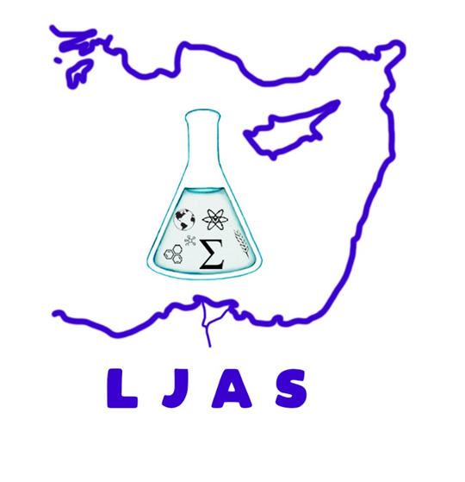
DECEMBER, 2023

CONTENTS
Original Articles

Merve Ayyıldız*, Zehra Meliha Tengiz, Bekir Ayyıldız

Evaluation of Farmers' Knowledge Level in Pesticide Use: The Case of Central District of Yozgat Province

Pages: 12 - 20

